The manuscript template of the European Solar Network Press

Ann B. Evans¹, John C. Williams²

¹University, City, Country
²Company, City, Country

E-mail: name@domain.edu

Abstract

Solar energy is radiant light and heat from the Sun that is harnessed using a range of ever-evolving technologies such as solar heating, photovoltaics, solar thermal energy, solar architecture, molten salt power plants and artificial photosynthesis. It is an essential source of renewable energy, and its technologies are broadly characterized as either passive solar or active solar depending on how they capture and distribute solar energy or convert it into solar power. Active solar techniques include the use of photovoltaic systems, concentrated solar power, and solar water heating to harness the energy. Passive solar techniques include orienting a building to the Sun, selecting materials with favorable thermal mass or light-dispersing properties, and designing spaces that naturally circulate air. The large magnitude of solar energy available makes it a highly appealing source of electricity. The United Nations Development Programme in its 2000 World Energy Assessment found that the annual potential of solar energy was 1,575–49,837 exajoules (EJ). This is several times larger than the total world energy consumption, which was 559.8 EJ in 2012.

Keywords: Solar energy, Photovoltaics, PV, Wind power, Concentrated solar thermal, CST

1. Section

The Earth receives 174 petawatts (PW) of incoming solar radiation (insolation) at the upper atmosphere [1]. Approximately 30% is reflected back to space while the rest is absorbed by clouds, oceans and land masses. The spectrum of solar light at the Earth's surface is mostly spread across the visible and near-infrared ranges with a small part in the near-ultraviolet [2]. Most of the world's population live in areas with insolation levels of 150–300 watts/m2, or 3.5–7.0 kWh/m2 per day.

Solar radiation is absorbed by the Earth's land surface, oceans – which cover about 71% of the globe – and atmosphere. Warm air containing evaporated water from the oceans rises, causing atmospheric circulation or convection. When the air reaches a high altitude, where the temperature is low, water vapor condenses into clouds, which rain onto the Earth's surface, completing the water cycle. The latent heat of water condensation amplifies convection, producing atmospheric phenomena such as wind, cyclones and anti-cyclones [3]. Sunlight absorbed by the oceans and land masses keeps the surface at an average temperature of 14 °C [4]. By photosynthesis, green plants convert solar energy into chemically stored energy, which produces food, wood and the biomass from which fossil fuels are derived [5].
The total solar energy absorbed by Earth's atmosphere, oceans and land masses is approximately 3,850,000 exajoules (EJ) per year [6]. In 2002, this was more energy in one hour than the world used in one year [7]. Photosynthesis captures approximately 3,000 EJ per year in biomass [8]. The amount of solar energy reaching the surface of the planet is so vast that in one year it is about twice as much as will ever be obtained from all of the Earth's non-renewable resources of coal, oil, natural gas, and mined uranium combined [9].

1.1. Subsection

The potential solar energy that could be used by humans differs from the amount of solar energy present near the surface of the planet because factors such as geography, time variation, cloud cover, and the land available to humans limit the amount of solar energy that we can acquire.

Geography affects solar energy potential because areas that are closer to the equator have a higher amount of solar radiation. However, the use of photovoltaics that can follow the position of the Sun can significantly increase the solar energy potential in areas that are farther from the equator. Time variation effects the potential of solar energy because during the nighttime, there is little solar radiation on the surface of the Earth for solar panels to absorb. This limits the amount of energy that solar panels can absorb in one day. Cloud cover can affect the potential of solar panels because clouds block incoming light from the Sun and reduce the light available for solar cells.

Besides, land availability has a large effect on the available solar energy because solar panels can only be set up on land that is otherwise unused and suitable for solar panels. Roofs are a suitable place for solar cells, as many people have discovered that they can collect energy directly from their homes this way. Other areas that are suitable for solar cells are lands that are not being used for businesses where solar plants can be established.

Solar technologies are characterized as either passive or active depending on the way they capture, convert and distribute sunlight and enable solar energy to be harnessed at different levels around the world, mostly depending on the distance from the equator. Although solar energy refers primarily to the use of solar radiation for practical ends, all renewable energies, other than Geothermal power and Tidal power, derive their energy either directly or indirectly from the Sun.

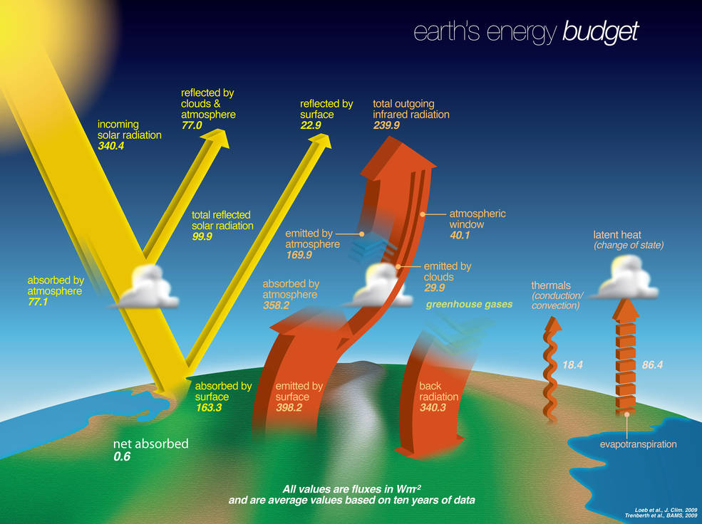
Fig. 1. Earth’s solar energy budget, Credits: NASA

Active solar techniques use photovoltaics, concentrated solar power, solar thermal collectors, pumps, and fans to convert sunlight into useful outputs. Passive solar techniques include selecting materials with favorable thermal properties, designing spaces that naturally circulate air, and referencing the position of a building to the Sun.

Table 1: Table captions (8 pt) should be justified as block and placed above the table
Table Header | Header | Header
Tables | Text | Text

Active solar technologies increase the supply of energy and are considered supply side technologies, while passive solar technologies reduce the need for alternate resources and are generally considered demand-side technologies.

2. Section

In the last two decades, photovoltaics (PV), also known as solar PV, has evolved from a pure niche market of small scale applications towards becoming a mainstream electricity source. A solar cell is a device that converts light directly into electricity using the photoelectric effect. The first solar cell was constructed by Charles Fritts in the 1880s. In 1931 a German engineer, Dr Bruno Lange, developed a photo cell using silver selenide in place of copper oxide. The electrical efficiency of a PV cell is a physical property which represents how much electrical power a cell can produce for a given Solar irradiance. The basic expression for maximum efficiency of a photovoltaic cell is given by the ratio of output power to the incident solar power (radiation flux times area)

$η={P_{max}}/{E∙A_{cell}}$ (Eq. 1)

Although the prototype selenium cells converted less than 1% of incident light into electricity, both Ernst Werner von Siemens and James Clerk Maxwell recognized the importance of this discovery. Following the work of Russell Ohl in the 1940s, researchers Gerald Pearson, Calvin Fuller and Daryl Chapin created the crystalline silicon solar cell in 1954. These early solar cells cost US$286/watt and reached efficiencies of 4.5–6%. By 2012 available efficiencies exceeded 20%, and the maximum efficiency of research photovoltaics was in excess of 40%.

References

- V. Smil, General Energetics: Energy in the Biosphere and Civilization, 1991
- Natural Forcing of the Climate System, Intergovernmental Panel on Climate Change, 2007
- K. Karuppu, V. Sitaraman, Solar Assessment Guidance: A Guide for Solar Trainee, Trainer & Assessor Examination, Notion Press, 2019
- Radiation Budget, NASA Langley Research Center, 2006
- R. Somerville, Historical Overview of Climate Change Science, Intergovernmental Panel on Climate Change, 2007
- W. Vermass, An Introduction to Photosynthesis and Its Applications, Arizona State University, 1998
- O. Morton, Solar energy: A new day dawning?: Silicon Valley sunrise, Nature. 443, 2006
- Energy conversion by photosynthetic organisms, Food and Agriculture Organization of the United Nations, 2008
- Exergy Flow Charts – GCEP, University of Stanford, 2018

